State of Michigan

OBRA Automation suite

Workflows 8

Initiate Level I for PAS

**Workflows with screenshots:**

The 3878 Form has changed for the section “Dementia”. The user needs to submit 3878 form with dementia. 4th question should be marked as Yes or NO.

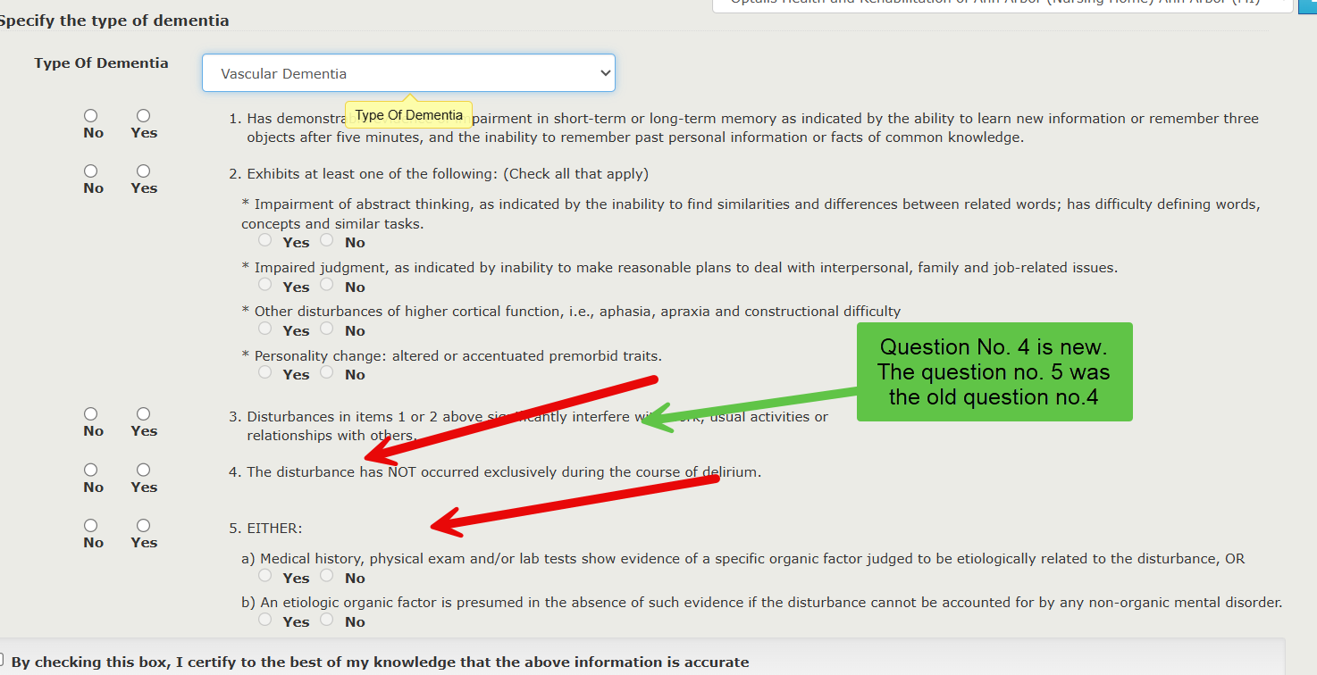

Initiate PAS, addition of new queue “ Send to NF”

Step 1: Submit a 3877 form

Step 2: Submit a 3878 form. The record goes to “Send to NF” queue

Step 3: Navigate to Send to NF queue.

Land on 3877-78 Detail Page

Scroll down and select “Optalis Ann Arbor” for the admission request to be sent to.

Login as Optalis Ann Arbor

Navigate to Requests queue and approve.

Hospital looks at the NF response queue.

Click on the PAS link from the record, land on 3877-78 Detail page. Click “Assign” .

Hospital is done with the flow. NF has to admit the consumer from the “Admissions’ queue.